1. Source Code

* Controller 🡪 Web.php
* Views 🡪 v_header.php
* Views 🡪 v_index.php
* Views 🡪 v_footer.php

1. URL :

http://localhost:8888/ci_hadi/index.php/web

1. 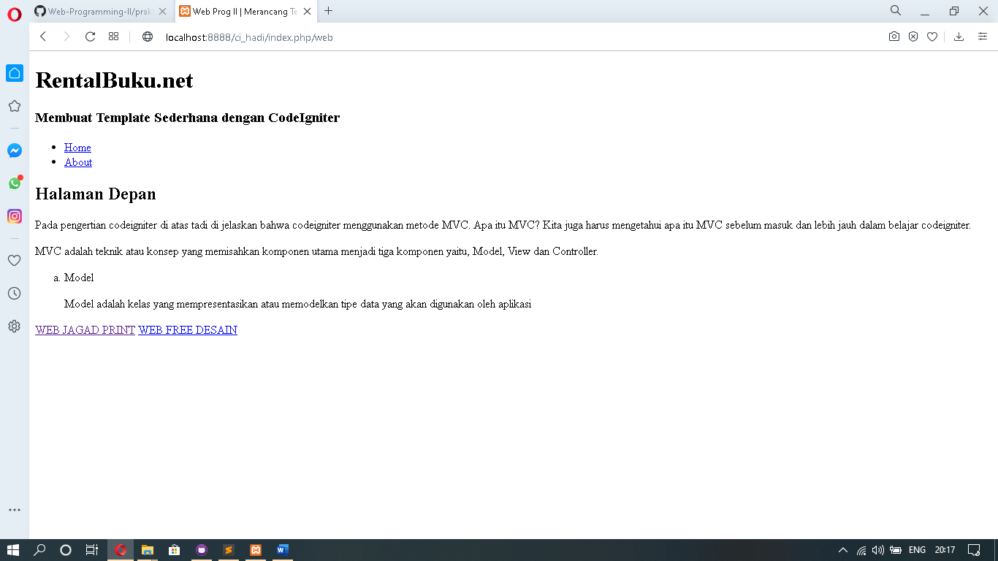Screen Shoot